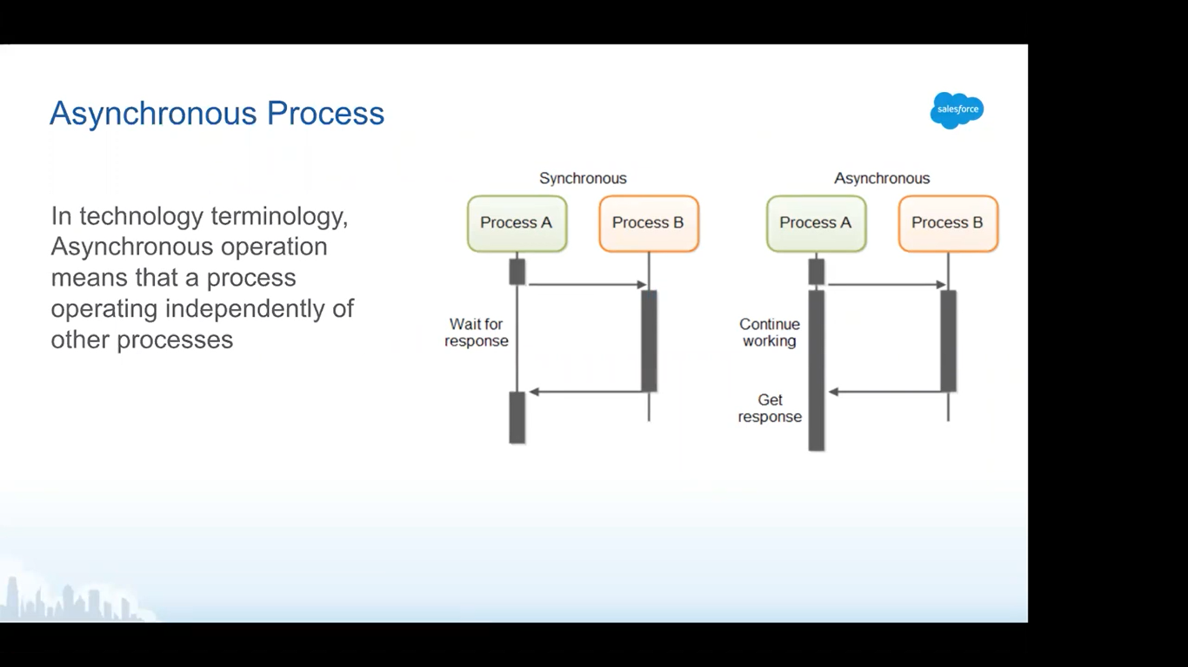

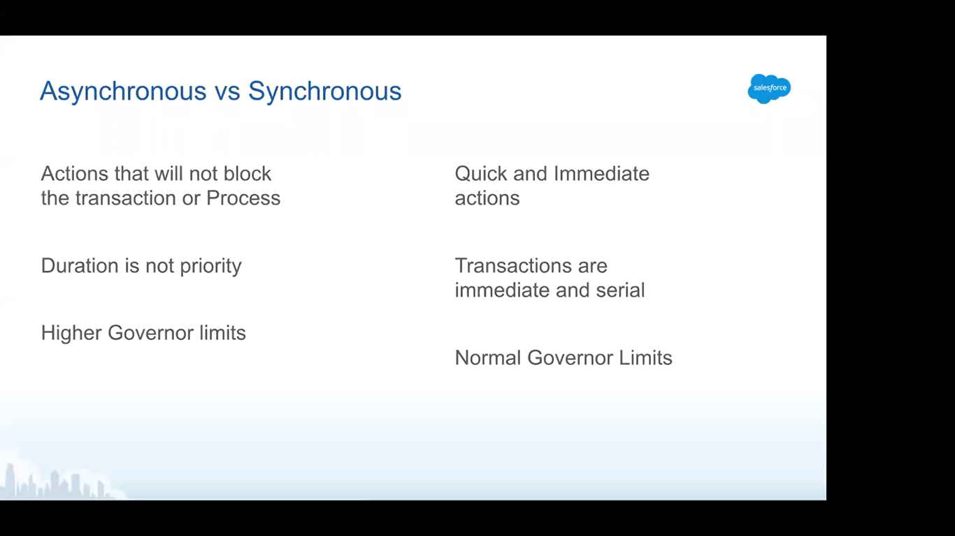

Governor Limits: it is a limit on the salesforce platform that will contain our resources.

Because its cloud based, salesforce has some limits pretty much everything (no. of inserts, selects, apex CPU time and so on...)

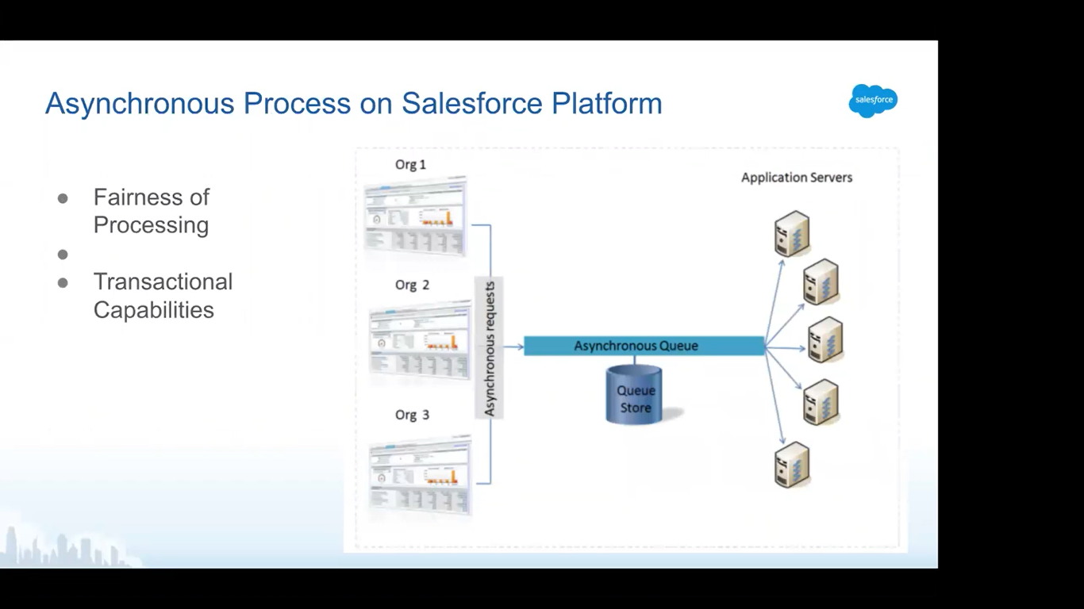

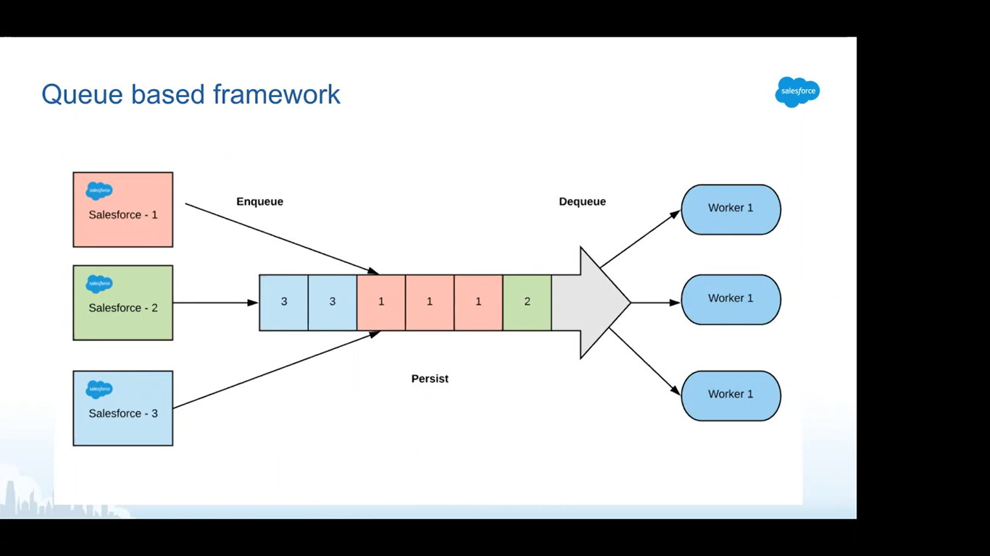

Enqueue: all the environments pushed some requests or jobs(future/batch), it goes into a queue. This process is called enqueuing.

Dequeue: Workers picks the jobs from the queue and send it to the processor. This process is called as dequeue.

Persist: the queue should not forget from where that particular job came and what are the properties of the job.

Worker: workers are taking the jobs from the queue and then sending it to the application server to be processed.

What if queue size is 10 and all the requests came from SF org1, what will happen to SF org2 and org3 when they are also sharing the same instance?

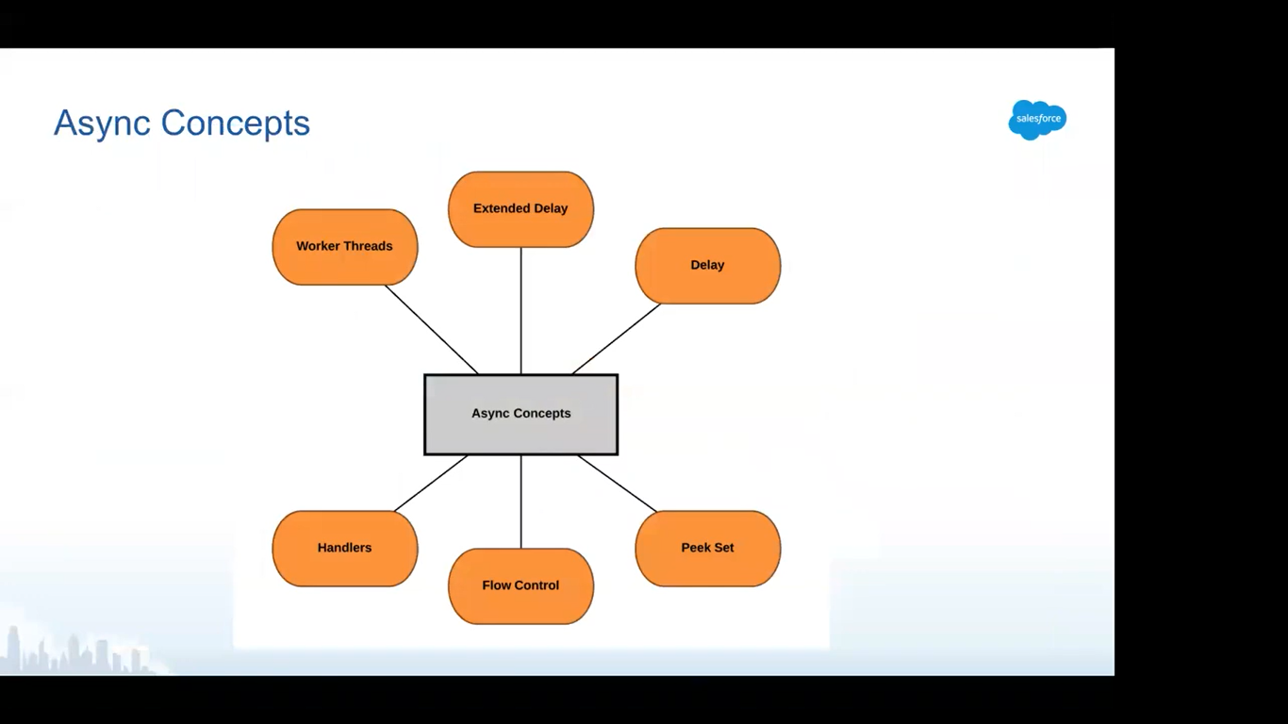

Worker thread: the one, picking up and dequeuing the requests from the queue.

Handlers: the one, processing the requests.

Delay(Multitenant fair share handling): more than the limit decided, other threads will be skipped because of control flow. This is called Delay.

Extended Delay:

Peek Set:

Flow Control: it is a limit which is decided for max no. of requests per org.

